

Connectivity Scenario for Hosted Payment Page Redirect Merchants

Table of Contents

1. Change History 2
2. Audience 4
3. Transaction part 4
3.1. “3D Pay Hosting” model scheme 4
3.2. Buying steps 5
3.3. Integration model in short 5
4. Merchant administration 6
5. Merchant integration with NestPay transaction and back-office system 6
1. Downloading the manuals from Merchant Center 6
2. Development of Merchant system 7
3. Checking/changing Store Key 7
4. Merchant is testing their integration 7
5. Switch to production 7
6. Notes: 8
7. Abbreviations 8

Change History

The following table shows the history of document changes.

Document  version | Description | Pages | Issue Date | Author
1.0 | Initial Version | 7 | 3th February 2016 | New Channels team
1.1 | API links are added | 9 | 9th May 2016 | New Channels team

Audience

For the merchants who don’t have their own payment page but uses ISPC Hosted Payment Page (HPP) model of integration.

Transaction part
This is for BIB merchants, who are using Hosted Payment Page redirect method. In this solution card details are entered on ISPC Hosted Payment Page (HPP).
The main characteristics of this way of integration are:
- payment page is on ISPC/BIB side
- card holder data are collected on ISPC/BIB side
- Merchant back-office system can be integrated with NestPay as back-office system - Merchant Center

“3D Pay Hosting” model scheme
Ecommerce buying steps for “3D Pay Hosting” model are described on below scheme:
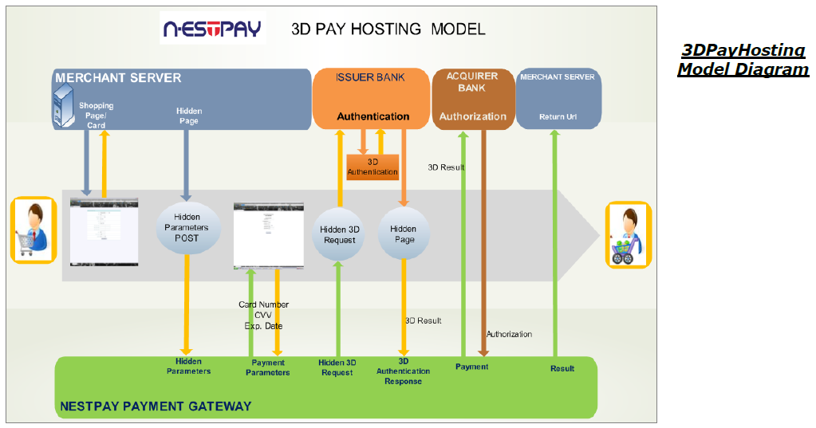
Note: payment page is on ISPC/BIB side
“3DPayHosting Model Diagram” represents buying steps, starting from the most left yellow arrow, in one part. The timeline starts on left and ends on right. There are three parties of ecommerce buying process on acquiring side. First one the Merchant system represented on upper part of diagram (blue boxes), Customer in the vertical middle (gray box) and NestPay of ISPC/BIB on lower part (green box).

Buying steps

“3D Pay Hosting” model on Diagram:
- Customer fill the shopping carts with products and, by Merchant system “Hidden Parameters POST”, it’s redirected to ISPC/BIB Hosted Payment Page (HPP)
- Customer enters Payment Parameters (card number, CVC2, expiry date) on secure NestPay Hosted Payment Page (HPP) of ISPC/BIB
- NestPay sends “Hidden 3D Request” to Issuer bank*
- Issuer bank sends “Hidden Page” to NestPay with 3-D Secure authentication result*
- NestPay sends “3D Result” parameters together with authorization message to BIB*
- BIB sends “Authorization” response to NestPay
- NestPay sends “Result” to Merchant “Return URL”
* Only for MasterCard, Maestro and VISA cards. For other card brands those steps are skipped.

Integration model in short

In “3D Pay Hosting” model HTTP request should be sent to NestPay “3D Pay Hosting” service link on TEST https://testsecurepay.intesasanpaolocard.com/fim/est3Dgate where 3-D Secure authentication will be checked and authorization message will be made.

Note: for PRODUCTION link is https://bib.eway2pay.com/fim/est3Dgate

HTTP requests are described in “ISPC_Nestpay_Merchant_Integration_3D_PayHosting.pdf” manual:
- “3D Pay Hosting” model enables processing of 3-D Secure card transactions and authorization:
  - easy to use HTTP Post method is supported for Merchant integration
  - settlement is done automatically by NestPay
- The customer personal information is not saved by the Merchant, because credit card information is collected on NestPay hosted payment page (HPP) of ISPC/BIB.
- ISPC/BIB SSL certificate is used so the customer can trust to NestPay hosted payment page
- Beside mandatory fields the Merchant can POST to NestPay optional data, such as username, user email or user id
The Result of 3-D Secure authentication check and authorization will be in NestPay response to Merchant URL.

However, for the merchants it’s possible to void, refund, to make post-authorization or to check order status by sending API requests to NestPay. For mentioned transaction types API requests should be sent to TEST link https://testsecurepay.intesasanpaolocard.com/fim/api.

Note: for PRODUCTION link is https://bib.eway2pay.com/fim/api

How to generate API following authorization requests is described in “ISPC_Nestpay_Merchant Integration API Manual.pdf” manual:
  - Secondary transactions (post-authorization, void, refund)
  - Order status query
  - Order history query
Note: Names for types of authorization and following transaction messages in comparison to other used names:
- preauthorization = preauthorization/authorization with completion
- auto-post-authorization/sale = authorization/ authorization without completion
- post-authorization = completion
- void = reversal/cancellation transaction
- refund = refund
- order status query = authorization check status/completion check status

Merchant administration

Merchant administration back-office system is NestPay Merchant Center.

There are two instances of Merchant Center:
- TEST https://testsecurepay.intesasanpaolocard.com/bib/report/user.login
- PRODUCTION https://bib.eway2pay.com/bib/report/user.login

It is used for:
- administration:
  - orders
  - transactions
  - users
  - merchant parameters for connection to NestPay transaction system
- searching:
  - downloading needed documents for integration with NestPay transaction system
  - bank information
  - help
and many other things related to NestPay transaction system. Details can be found in “Inhouse_NestPay_MerchantCenterUserManual.pdf” manual.

Merchant integration with NestPay transaction and back-office system

In following paragraphs will be described the main steps of merchant integration, with links and documents for integration.

Downloading the manuals from Merchant Center

Login to test Merchant Center with Merchant Id, Username and Password for Merchant Administrator role provided by BIB on TEST link https://testsecurepay.intesasanpaolocard.com/bib/report/user.login and download the manuals.

Note: for PRODUCTION link is https://bib.eway2pay.com/bib/report/user.login

There are four main manuals inside Integration manuals.zip file:
- “ISPC_Nestpay_Merchant_Integration_3D_PayHosting.pdf” - transaction manual for 3-D Secure HTTP POS requests and responses with explanations of mandatory/optional parameters and examples
- “ISPC_Nestpay_Merchant Integration API Manual.pdf” - transaction manual for authorization API requests and responses with explanations of mandatory/optional parameters and examples
- “Inhouse_NestPay_MerchantCenterUserManual.pdf” - merchant administration manual for Merchant Center back-office system
- “Merchant Integration Test Cases and Test Cards - eway2pay_vx.y.xls” - list of test cases and needed card data for testing of merchant integration, where “…vx.y…” is version of the document (e.g. “…v1.0…” denotes “version 1.0” of the manual)

Development of Merchant system

Develop test system for integration with NestPay transaction system following rules and examples from downloaded manuals.
For “3D Pay Hosting” model of integration merchant should send all mandatory parameters values listed in “ISPC_Nestpay_Merchant_Integration_3D_PayHosting.pdf”. Those values/data are collected on NestPay Hosted Payment Page (HPP) of ISPC/BIB. There are also optional data mentioned in those manuals which could be sent to NestPay.
While developing merchant site and payment page Merchant must follow rules provided by BIB. Before production BIB will check Merchant site and payment page.

Checking/changing Store Key

For making transactions in “3D Pay Hosting” model Merchant ID, already provided in one of previous steps, and Store Key are needed. Store Key could be found in Merchant Center TEST link https://testsecurepay.intesasanpaolocard.com/bib/report/user.login under Administration tab Change Store Key link in Old Store Key parameter.

Note: for PRODUCTION link is https://bib.eway2pay.com/bib/report/user.login

Merchant is testing their integration

Merchant administrator must make mandatory test cases with test cards by sending request to 3D Pay Hosting services on TEST link https://testsecurepay.intesasanpaolocard.com/fim/est3Dgate
on NestPay for 3-D Secure authentication (only for MasterCard, Maestro and VISA cards) and after that for authorization, both actions in a single step.

Note: for PRODUCTION link is https://bib.eway2pay.com/fim/est3Dgate

“Merchant Integration Test Cases and Test Cards - eway2pay_vx.x.xls” could be downloaded from Merchant Center TEST link https://testsecurepay.intesasanpaolocard.com/bib/report/user.login in Help panel under link Documents. Which test cases are mandatory for the Merchant depends on functionalities and transaction types used by merchant. After all mandatory tests are done Merchant should contact BIB to approve test process. If some test is failed then must be repeated.

Switch to production

When all previous steps are successfully finished Merchant will get production parameters (Merchant Id, User Name and Password) from BIB, also merchant should repeat 3rd step in production environment and after that will be switched to production. Before that Merchant will not have possibility to make production transactions.

Notes:
- Do not use test cards on production environment
- For any question related to integration BIB contact information on Merchant Center links
  - TEST https://testsecurepay.intesasanpaolocard.com/bib/report/user.login or
  - PRODUCTION https://bib.eway2pay.com/bib/report/user.login
- The Merchant security parameters (Merchant ID, User Name and Password) are different for test and production environment

Abbreviations

IPSP = internet payment service provider with more than one merchant connected to its system
MPI = merchant plug-in
3-D Secure authentication = secure way of card holder authentication (usually one time password) on the bank which issued the card used for payment in ecommerce transaction
NestPay = new ecommerce platform service for BIB merchants provided by Intesa Sanpaolo Card
ISPC = Intesa Sanpaolo Card
HPP = hosted payment page, hosted by ISPC

